[1]01_CCP-10863-Card Activation-ValidateActivationOfPremiaCard_OTPLvl2_Chrome

Test data

ccpTest99 customer number 94090999

Premia card number 0005290289953331367 CVV 344

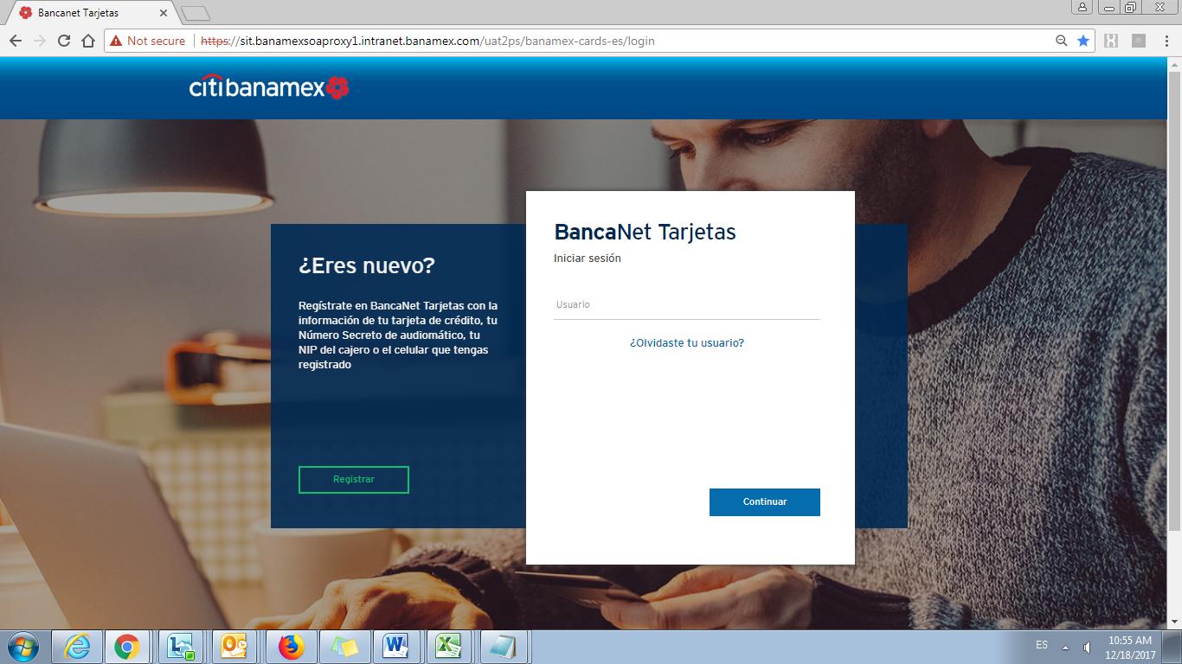

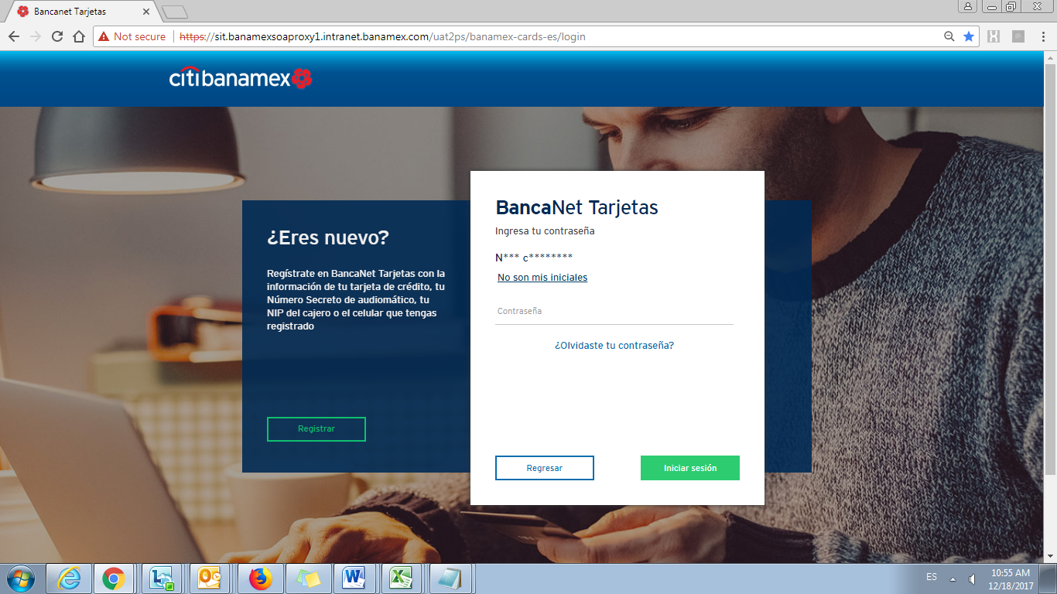

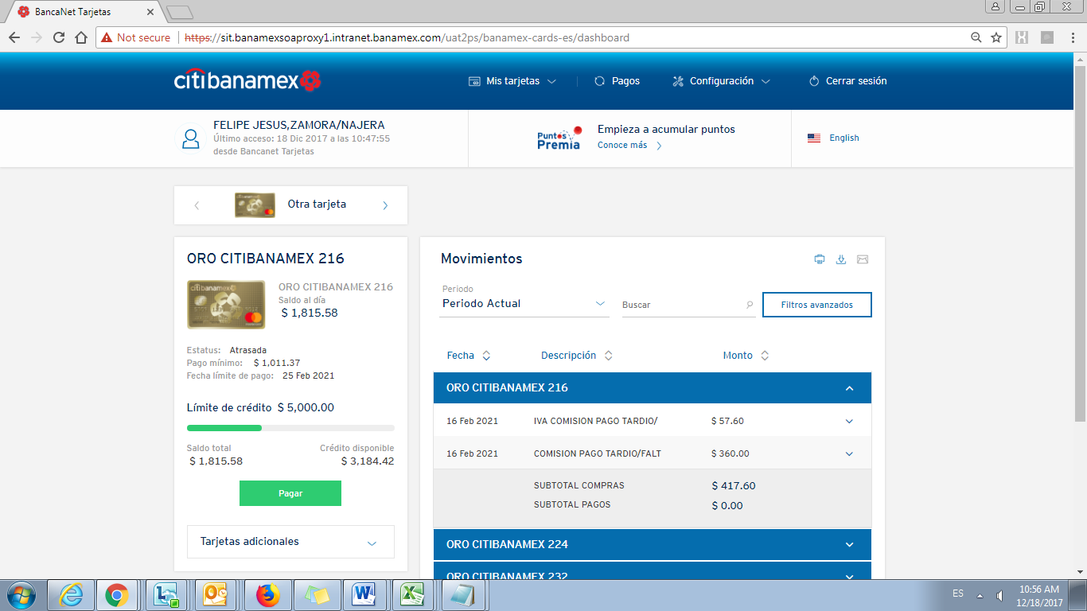

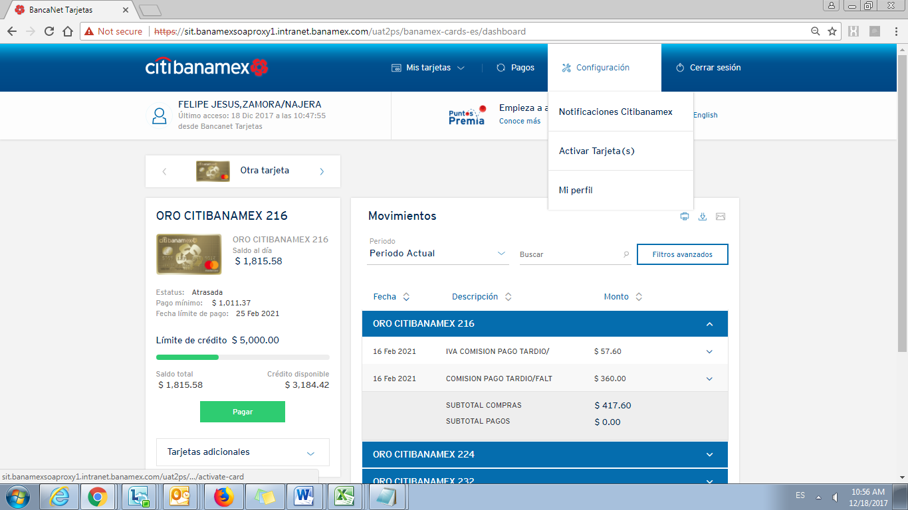

It is not possible to select the checkbox in card activation module for Premia cards, and I am not able to activate the premia cards due this issue:

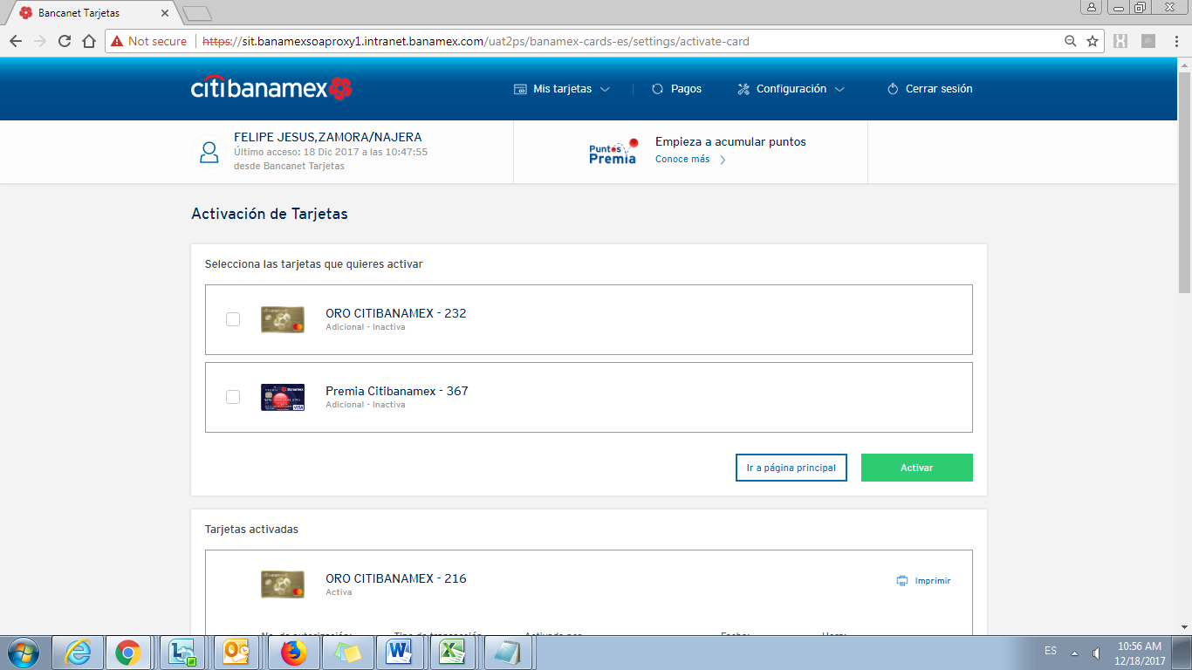

When is selected the checkbox in other card , it is displayed the CVV input text correctly

